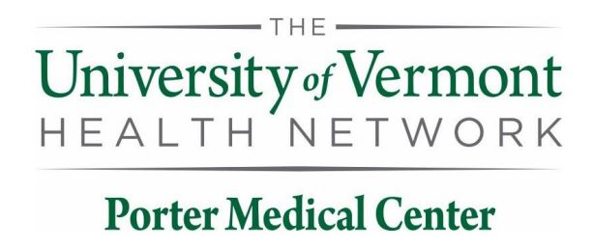

UVMHN Porter Medical Center Laboratory

115 Porter Drive

Middlebury, VT 05753

**Contacts**

Porter Laboratory: (802) 388-4747 or Ext. 4747

*Medical Director*: Jason Brazelton, MD [OFFICE] (802) 371-4142

[BEEPER] (802) 847-1000 #5262

[CELL] (802) 249-5574

*Administrative Director:* Lia McFarline, MT (AMT) [OFFICE] (802) 388-4716 or Ext 4716

*Support Services Supervisor*: Liza Pellerin [OFFICE] (802) 388-3417 or Ext 3417

*QA/QI Coordinator & Physician Office Coordinator*:

Ashley Laberge, MLS (ASCP) [OFFICE] (802) 388-4761 or Ext 4761

**Laboratory Departments**

Blood Bank/UA x 4361

Chemistry x 4249

Hematology x 4363

Microbiology x 4365

Pathology (UVM) (802) 847-3795

Cytology (UVM) (802) 847-5136