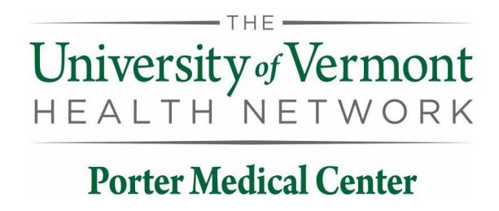

UVMHN Porter Medical Center Laboratory
115 Porter Drive
Middlebury, VT 05753

Contacts
Porter Laboratory: (802) 388-4747 or Ext. 4747

Medical Director: Vlada Alexeeva, MD [CELL] (802) 399-4469

Administrative Director: Lia McFarline, MT (AMT) [OFFICE] (802) 388-4716 or Ext 4716

Support Services Supervisor: Liza Pellerin [OFFICE] (802) 388-3417 or Ext 3417

QA/QI Coordinator & Point of Care Coordinator:
Ashley LaBerge, MLS (ASCP) [OFFICE] (802) 388-4761 or Ext 4761

Laboratory Departments

Blood Bank/UA x 4361
Chemistry x 4249
Hematology x 4363
Microbiology x 4365
Pathology (UVM) (802) 847-3795
Cytology (UVM) (802) 847-5136

